**Chapter 9 - Immunity and the Immune System**

**All Lectures Uploaded on YouTube:**

[**https://tinyurl.com/fkm10-biology**](https://tinyurl.com/fkm10-biology)

## 

### **9.1. Immunity**

### Immunity is the body’s natural ability to resist, fight, or eliminate infections, diseases, and harmful substances such as bacteria, viruses, fungi, and parasites. It is like a defence shield that keeps the body safe from harmful invaders called *pathogens*.

**9.1.1. Roles of the Immune System**

A well-functioning immune system keeps us healthy by performing the following major roles:

1. **Recognition of Foreign Antigens:** The immune system identifies substances that do not belong to the body (called *antigens*).  
    These may include bacteria, viruses, or toxins. This step helps the body distinguish between “self” and “non-self”.
2. **Activation of Immune Response:** Once an antigen is detected, the immune system activates various defence mechanisms to destroy it, like calling an army into action.
3. **Elimination of Pathogens:** The immune cells directly attack and remove pathogens and harmful substances from the body through processes like *phagocytosis* or *antibody neutralisation*.
4. **Regulation of Immune Response:** The system ensures that immune reactions do not become overactive or underactive.  
    For example, too much immune activity may cause allergies or autoimmune diseases, while too little leads to infections.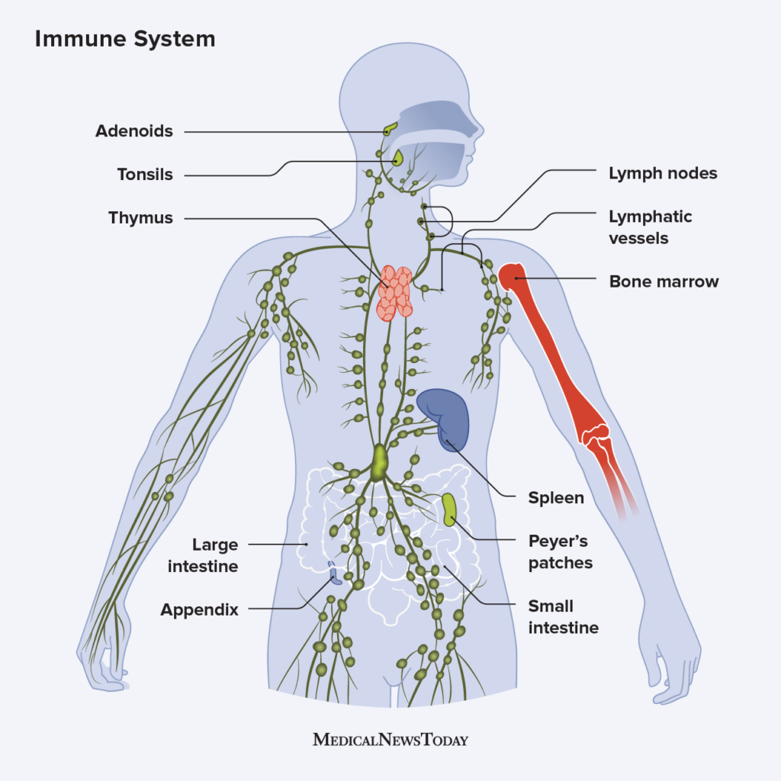
5. **Memory:** After exposure to a pathogen, the immune system “remembers” it. This helps produce a faster and stronger response if the same pathogen invades again — this is the basis of *immunity after vaccination*.
6. **Surveillance:** The immune system constantly monitors body cells to detect any abnormal or cancerous changes early.
7. **Inflammation:** When tissue is damaged or infected, inflammation helps isolate the affected area, destroy pathogens, and start the healing process. Redness, heat, and swelling are part of this response.
8. **Antibody Production:** Special immune cells called *B cells* produce antibodies that specifically target and neutralise antigens.
9. **Cell-Mediated Immunity:** *T cells* and *macrophages* attack infected or cancerous cells directly without using antibodies.
10. **Tissue Repair:** The immune system helps rebuild and restore damaged tissues after infections or injuries.
11. **Self-Tolerance:** The immune system learns to differentiate between the body’s own cells and foreign ones, preventing it from attacking itself.
12. **Cancer Prevention:** Immune cells identify and destroy abnormal or pre-cancerous cells daily before they grow uncontrollably.
13. **Allergy Control:** Sometimes, the immune system overreacts to harmless substances like pollen or dust — this causes allergies.
14. **Clotting Assistance:** Immune responses help control bleeding and promote wound healing when blood vessels are damaged.
15. **Removal of Cell Debris:** The immune system clears away dead or damaged cells to keep tissues healthy and clean.

### **9.1.2. The Immune System**

The immune system is an **extensive network of organs, tissues, and cells** that act together to protect the body.  
 It detects harmful invaders and launches a defensive attack. It functions much like a **police force**, always on patrol and ready to respond to danger anywhere in the body.

However, it isn’t perfect — sometimes, it can mistakenly attack harmless substances (like in allergies).

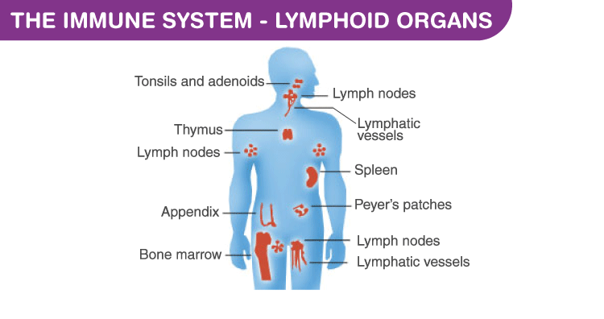

## **9.2. Organs of the Immune System**

These organs work together to produce and regulate immune cells, transport them around the body, and destroy pathogens.

1. **Bone Marrow**
   * Found inside bones; soft, spongy tissue that produces **red blood cells, white blood cells, and platelets**.
   * It is the **birthplace** of immune cells.
   * **B cells and T cells** are both formed here, but only B cells mature in the bone marrow.
   * **T cells** leave and mature in the **thymus**.
2. **Thymus**
   * A small gland located behind the breastbone where **T cells mature**.
   * It helps train T cells to recognise self and non-self substances properly.
3. **Lymph Nodes and Lymphatic Vessels**
   * These form a network throughout the body that carries *lymph fluid* (rich in immune cells).
   * **Lymph nodes** act as **filters**, trapping and destroying germs.
   * They also allow **B and T cells** to communicate and coordinate responses.
   * Swollen lymph nodes indicate the body is fighting an infection.
4. **Spleen**
   * Located near the stomach, the spleen filters blood and removes old or damaged blood cells.
   * It also stores white blood cells and fights bacteria and viruses.
5. **Liver**
   * Produces proteins known as **complement proteins** that help destroy microbes.
   * Contains **phagocytic cells** that capture and digest bacteria circulating in the blood.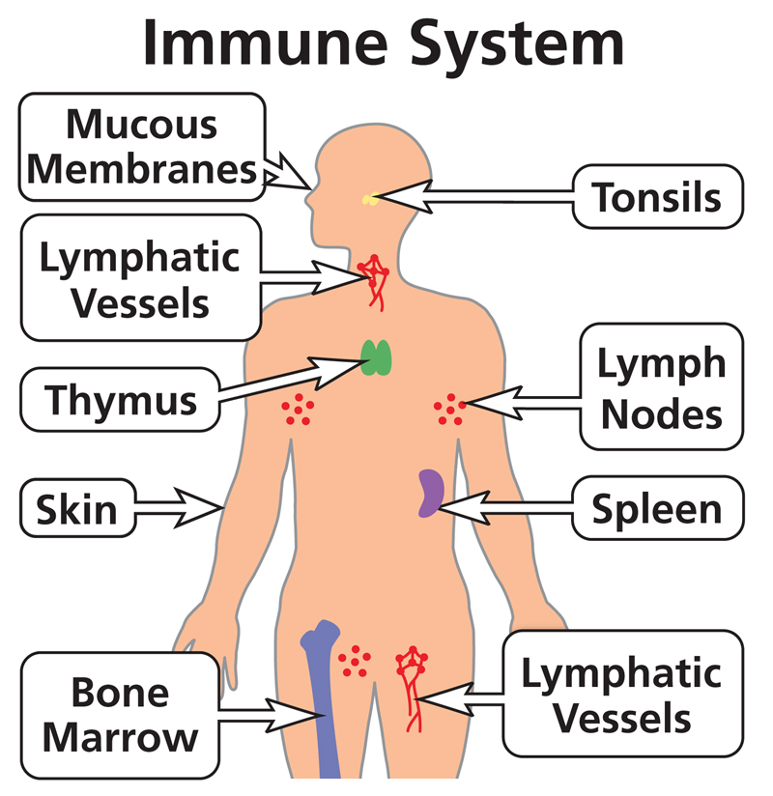
6. **Tonsils and Adenoids**
   * Found in the throat and nasal passages.
   * They trap pathogens entering through the mouth or nose — acting as a **first line of defence**.
7. **Skin**
   * Acts as a **physical barrier** against microbes.
   * The top layer (epidermis) has tightly packed cells, keratin, and an acidic pH that prevents bacterial growth.
   * Sweat and oil glands also contain substances that kill microbes.
8. **Mucous Membranes**
   * Line the digestive and respiratory tracts.
   * They secrete **mucus** that traps microbes, dust, and particles.
   * Tiny hair-like structures (*cilia*) move the mucus out of the body.

## **9.2.1. Types of Immune Cells and Their Roles**

The immune system relies on **white blood cells (WBCs)**, which defend the body from infections.  
 They are of **three main types:** granulocytes, monocytes, and lymphocytes.

### **I. Granulocytes**

Contain granules with enzymes that digest pathogens.

1. **Neutrophils:**
   * The most abundant WBCs.
   * Quickly reach infection sites and destroy microbes by *phagocytosis* (engulfing and digesting them).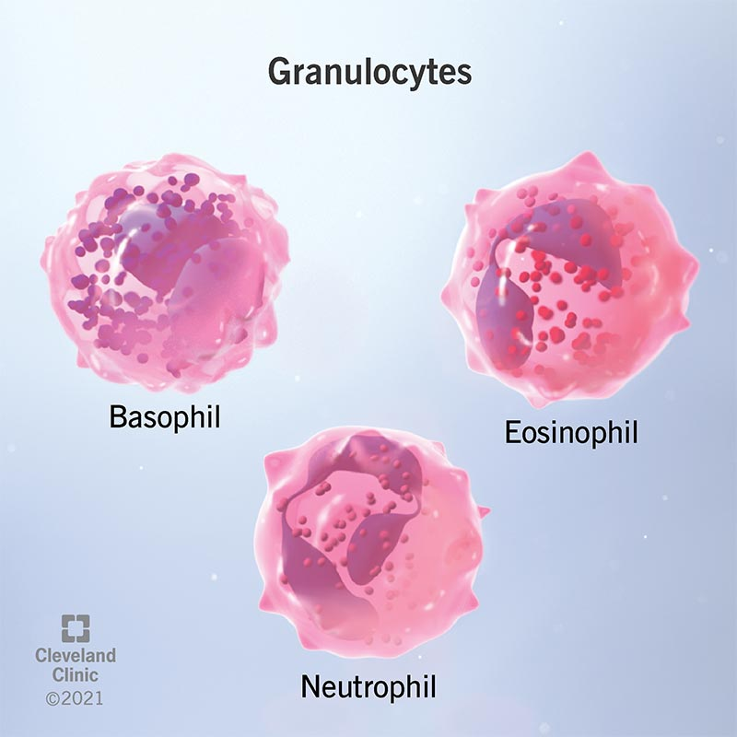
2. **Basophils:**
   * Protect the body against allergens and parasites.
   * Release chemicals like **histamine**, which cause inflammation and help improve blood flow to infected areas.
3. **Eosinophils:**
   * Fight **parasites and allergens**.
   * Also helps reduce allergic reactions by controlling inflammation.

### **II. Monocytes**

* The largest type of WBC.
* Circulate in the blood, then migrate into tissues to become **macrophages** or **dendritic cells**.

1. **Macrophages:**
   * “Big eaters” that engulf and digest bacteria, viruses, and dead cells.
   * They also *present antigens* to activate other immune cells.
2. **Dendritic Cells:**
   * Specialised in detecting antigens and presenting them to *T cells*.
   * Act as messengers between the innate and adaptive immune systems.

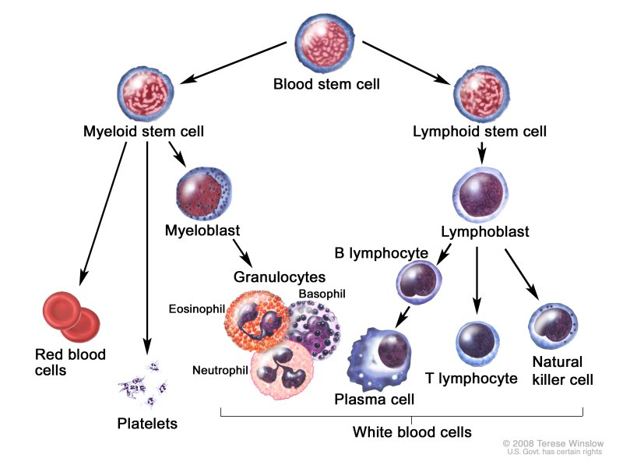

### **III. Lymphocytes**

These are key players in *adaptive immunity* — providing long-term protection.

1. **Natural Killer (NK) Cells:**
   * Kill virus-infected and cancerous cells directly.
2. **B Cells:**
   * Produced and mature in bone marrow.
   * Recognise specific antigens and produce **antibodies**.
   * Two main types:
     + **Plasma Cells:** Produce antibodies that attach to pathogens.
     + **Memory B Cells:** Remain in the body to provide faster defence upon re-infection.
3. **T Cells:**
   * Formed in bone marrow, mature in the thymus.
   * Four main types:
     + **Cytotoxic T Cells:** Destroy virus-infected or cancer cells.
     + **Helper T Cells:** Activate other T and B cells to strengthen the response.
     + **Memory T Cells:** Stay in the body and remember pathogens for future defence.
     + **Suppressor T Cells:** Stop the immune response after the infection is gone to prevent damage to healthy cells.

## **9.2.2. Components of the Immune System**

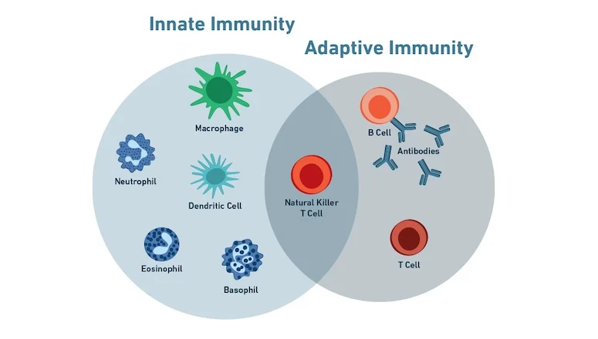

The immune system has **two main divisions:**

1. **Innate Immune System:**
   * Present from birth.
   * Provides **non-specific** defence (acts against any pathogen).
   * Includes skin, mucous membranes, and general inflammatory responses.
   * Acts as the **first line of defence**.
2. **Adaptive Immune System:**
   * Develops after exposure to specific pathogens or through vaccination.
   * Provides **specific** and long-term protection.
   * Includes B and T lymphocytes that “remember” pathogens.

‘Antibodies are protein molecules that fit antigens like a *lock and key*, neutralising them and preventing further harm.’

### **9.2.2. Innate Immune System**

The innate immune system is the body’s **natural, inborn defense mechanism** that provides **immediate protection** against pathogens (disease-causing organisms). It is **non-specific**, meaning it fights all types of invaders in the same way and does not depend on previous exposure to a pathogen.

#### **1. First Line of Defence**

**Purpose:** To prevent pathogens from entering the body.

**Components:**

* **Skin:** Acts as a **physical barrier** that prevents microbes from entering. Sebum and sweat on the skin contain antibacterial substances.  
   *Example:* When you get a minor cut, bacteria can enter through the broken skin — but intact skin prevents this.
* **Mucous membranes:** Found in the **respiratory, digestive, urinary, and reproductive tracts**. Mucus traps microbes and dust particles.  
   *Example:* The sticky mucus in the nose traps dust and germs; sneezing expels them.
* **Chemical barriers:**
  + **Stomach acid** destroys pathogens swallowed with food or saliva.
  + **Lysozyme enzyme** in tears and saliva breaks down bacterial cell walls.
  + **Earwax** and **nasal hairs** trap and block pathogens.
* **Biological barriers:** Beneficial bacteria (normal flora) on skin and in intestines outcompete harmful microbes for nutrients and space.

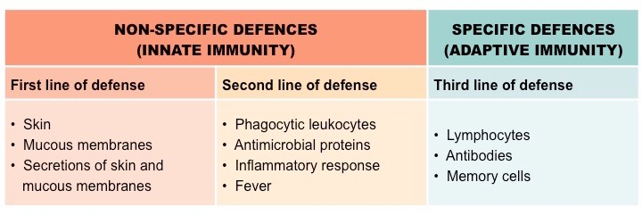

#### **2. Second Line of Defence**

If a pathogen breaches the first line (like through a cut), the **second line of defence** activates. It is **still non-specific** but acts internally.

**Main Components:**

1. **Phagocytic Cells:**
   * *Phagocytes, neutrophils, and natural killer (NK) cells* engulf and destroy pathogens.
   * This process is called **phagocytosis**.  
      *Example:* White blood cells attack bacteria in an infected wound.
2. **Inflammation:**
   * Triggered when tissues are injured or invaded by pathogens.
   * Causes redness, heat, swelling, and pain.
   * Increases blood flow and allows more immune cells to reach the infected area for healing.  
      *Example:* Swelling and redness around a mosquito bite.
3. **Fever:**
   * The body increases temperature to make the environment less favorable for bacteria and viruses to grow and reproduce
   * Also enhances immune reactions.  
      *Example:* Fever during a flu helps your body fight infection more efficiently.
4. **Protective Proteins:**
   * *Complement proteins* and *interferons* destroy pathogens or stop viral replication.
   * **Interferons** signal nearby cells to produce antiviral defenses.
   * **Complement proteins** coat pathogens to make them easier targets for phagocytosis.

#### **3. Third Line of Defence / Adaptive (Acquired) Immune System**

This is the **specific defense system** that develops after exposure to pathogens or through vaccination. It recognizes, targets, and “remembers” specific antigens.

**Main Immune Cells:**

* **B-cells (B lymphocytes):** Produce antibodies that neutralize or destroy pathogens.
* **T-cells (T lymphocytes):** Identify and kill infected or abnormal cells.

**How it works:**

1. When the body encounters a new pathogen, it creates **antibodies** specific to that pathogen.
2. **Memory cells** are formed to “remember” the pathogen.
3. On re-exposure, the immune system responds faster and stronger (secondary immune response).

**Example:** Once you recover from chickenpox, your body remembers the virus. If exposed again, your immune system prevents reinfection.

**Boosting Adaptive Immunity:**

* Vaccinations
* Balanced diet, regular exercise, and proper sleep
* Avoiding smoking and alcohol

### **9.3. Functions of Adaptive Immunity**

Adaptive immunity provides **specific, targeted, and long-lasting defence** against pathogens.  
 Its functions include:

1. **Recognition:**
   * Detecting specific antigens on pathogens.  
      *Example:* T-cells recognize the spike protein on the COVID-19 virus.
2. **Activation:**
   * Activating immune cells (B-cells and T-cells) to respond effectively.  
      *Example:* After a vaccine, helper T-cells activate B-cells to make antibodies.
3. **Elimination:**
   * Destroying pathogens or infected cells using antibodies and cytotoxic T-cells.  
      *Example:* Antibodies neutralize toxins produced by bacteria like *Clostridium tetani* (tetanus).

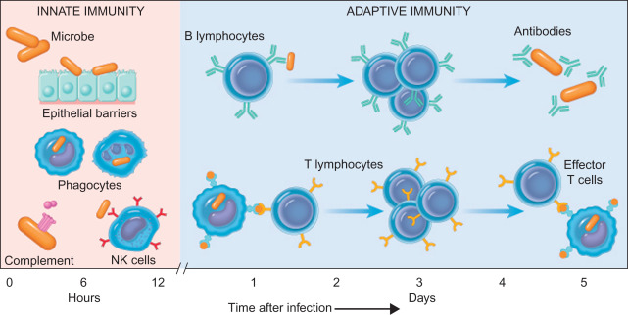

1. **Memory:**
   * Remembering pathogens for faster future responses.  
      *Example:* Once vaccinated for hepatitis B, the body remembers and defends against future infections.
2. **Specificity:**
   * Each immune response targets a specific pathogen without harming other body cells.  
      *Example:* Antibodies against the flu virus don’t attack bacteria.
3. **Adaptation:**
   * Improves the immune response with repeated exposure.  
      *Example:* Repeated flu exposures lead to stronger immune memory.
4. **Protection:**
   * Provides long-term defense against specific pathogens and prevents reinfection.  
      *Example:* Immunity from measles vaccine can last a lifetime.

### **9.4. Vaccines**

Vaccines introduce a **harmless form of a pathogen (antigen)** to the body, stimulating a specific immune response without causing illness.  
 This prepares the immune system to recognize and fight the real pathogen in the future.

**How Vaccines Work:**

1. The vaccine introduces weakened or dead pathogens.
2. The immune system produces **antibodies** against the antigen.
3. **Memory cells** are formed.
4. Upon later exposure, the immune response is faster and stronger (secondary immune response).

**Examples of Vaccines:**

1. **Influenza (Flu) Vaccine:** Protects against seasonal influenza viruses; updated yearly.  
    Reduces risk of severe flu, hospitalization, and death.  
    *Example:* Elderly people are advised to get a flu shot annually.
2. **MMR Vaccine:** Protects against **measles, mumps, and rubella**.  
    Prevents epidemics and severe complications such as brain infection (encephalitis).  
    *Example:* Children typically receive MMR vaccine at 12–15 months.
3. **DTaP Vaccine:** Protects against **diphtheria, tetanus, and pertussis (whooping cough)**.  
    Prevents bacterial infections and their complications.  
    *Example:* Booster doses are given during childhood.
4. **COVID-19 Vaccines:** Use mRNA or viral vector technology to protect against SARS-CoV-2.  
    Greatly reduce risk of severe illness, hospitalization, and death.  
    *Example:* Pfizer and Moderna vaccines.
5. **Additional Example – HPV Vaccine:** Protects against **Human Papillomavirus**, which causes cervical and other cancers.  
    Recommended for adolescents before exposure to the virus.

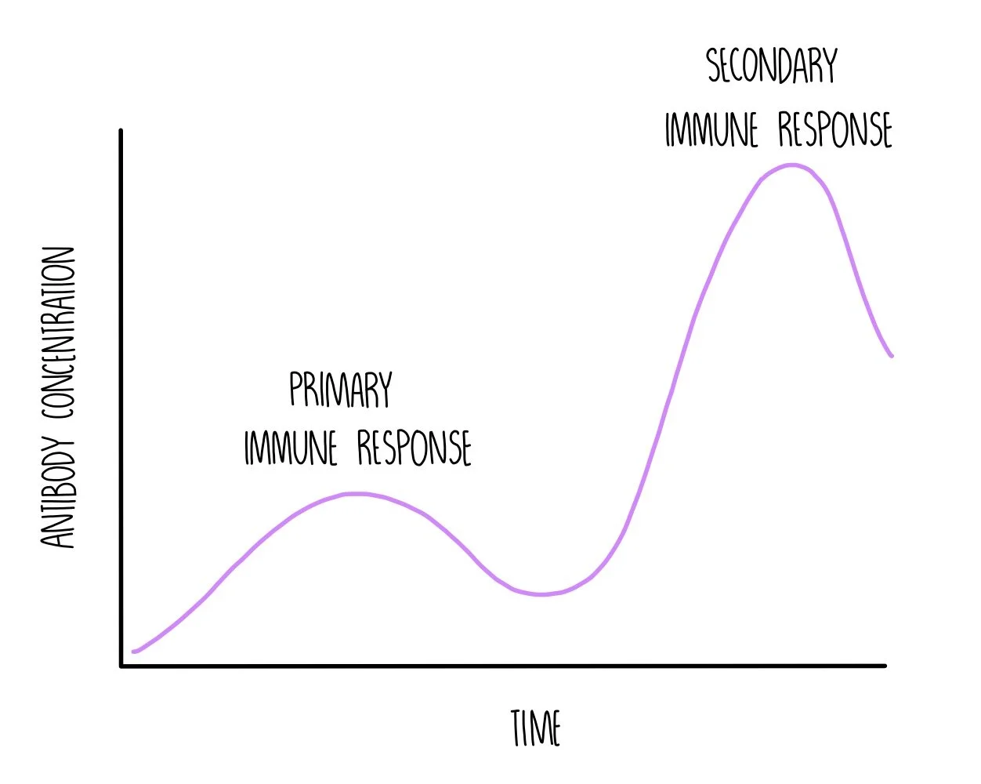

### **Primary and Secondary Immune Response**

* **Primary Response:** Occurs after the first exposure or the first vaccination.  
   The immune system takes time to produce antibodies, so the response is slow and weak.
* **Secondary Response:** After a booster or second exposure, memory cells activate quickly.  
   Response is faster, stronger, and lasts longer.  
   This shows how vaccination builds long-term immunity.

**9.5. Allergies**

An allergy is an overreaction of the immune system to a harmless substance, known as an allergen. When an allergen enters the body, the immune system mistakenly identifies it as harmful and attempts to fight it off, leading to an allergic reaction.

**Airborne allergens**

* Pollen: From trees, grasses, and weeds, which can cause seasonal allergies.
* Dust mites: Microscopic organisms that live in dust and are a common indoor allergen.
* Mold: Found indoors and outdoors, mold releases spores that can trigger allergic reactions.
* Animal dander: Tiny flakes of skin or hair from pets like cats and dogs.

**Foods**

* Common culprits: Peanuts, tree nuts, wheat, soy, milk, eggs, fish, and shellfish are some of the most common food allergens.

**Insect stings and bites**

* Venom: Stings from insects like bees and wasps can cause allergic reactions.

**Medications**

* Commonly associated drugs: Antibiotics (like penicillin), aspirin, and other non-steroidal anti-inflammatory drugs (NSAIDs) are frequent triggers.

**Contact allergens**

* Skin irritants: Certain substances that cause a reaction upon contact with the skin include poison ivy, certain metals (like nickel in jewelry), latex, and ingredients in soaps, shampoos, and cosmetics.

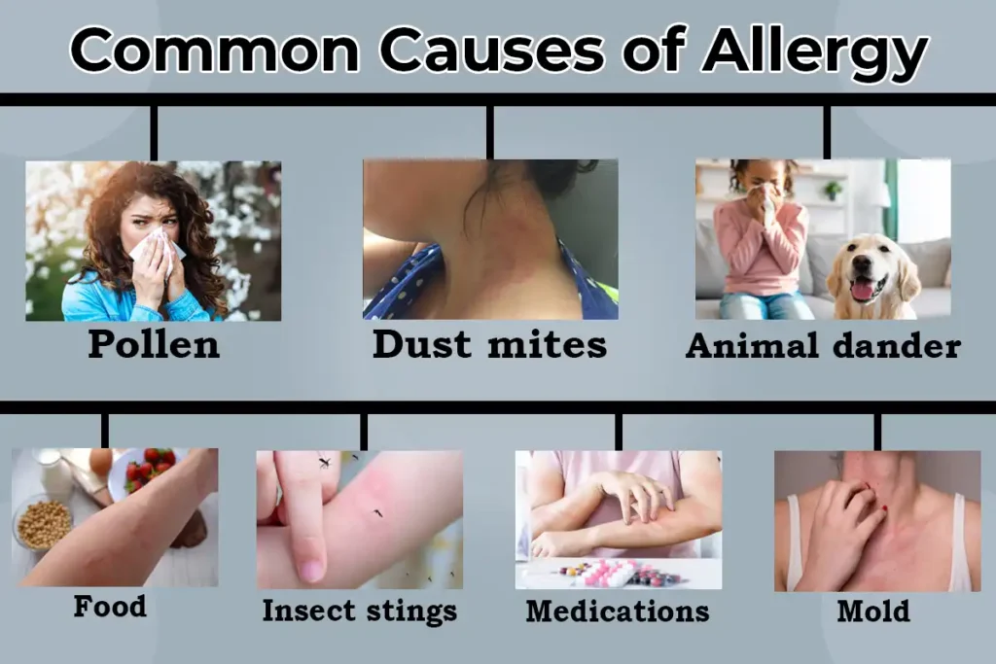

**9.5.1. Common Types of Allergies**

Allergies can be broadly classified into four types:

1. **Inhalation allergies:** Airborne and pet allergens can cause respiratory issues on inhalation.

2. **Ingestion allergies:** Food and medications can cause gastrointestinal issues on ingestion.

3. **Skin contact allergies:** Plants, latex and household chemicals can cause skin problems on skin contact.

4. **Injection allergies:** Insect stings and injectable medicines can cause skin issues on injection.

5. Anaphylaxis: Anaphylaxis is a severe, life-threatening allergic reaction. It can happen seconds or minutes after you've been exposed to something you're allergic to. Peanuts or bee stings are examples.

